**LEBANESE AMERICAN UNIVERSITY**

**USAID – HIGHER EDUCATION SCHOLARSHIP PROGRAM**

**HES - Volunteering Program Verification Form**

This form is to be used to document volunteering hours. If a student volunteers for multiple organizations, a separate form must be used for each organization. **This form must be turned in by the 28th of each month, the latest.**

I certify that the scholar Sary Jabre completed a total of 5 hours of service at InnovaThrive.

The hours were completed hours as per the below:

Hours # 5 (date) _2/12 – 6/12_ (initials of supervisor) __A.K.___

Hours # 0 (date) _9/12 – 13/12_ (initials of supervisor) __A.K.___

Hours # 0 date) _16/12 – 20/12 (initials of supervisor) __A.K.___

Hours # 0 date) _23/12 - 27/12 (initials of supervisor) __A.K.___

Brief description of the activities the scholar performed or participated in:

I have conducted a research on the topic of Ai in Personalized Virtual Shopping Experience, where I searched for the pros and cons of Ai in this domain, what challenges are being faced, how is this being applied nowadays, and what to expect as future research regarding this topic so that we try to eliminate the disadvantages and focus on ensuring the beneficial process of Ai in this field.

Written feedback about the scholar’s performance:

Sary Jabre’s research on AI in personalized virtual shopping experiences provided valuable insights into the evolving landscape of online retail. His comprehensive analysis of AI’s advantages, disadvantages, and future potential reflects a strong understanding of consumer behavior and technological advancements.

Please rate the overall performance of the scholar at your organization:

|  |  |  |  |
| --- | --- | --- | --- |
|  | Mastery (5) | Proficient (3) | Emerging (1) |
| **Problem solver** | X |  |  |
| **Engaged & Committed** | X |  |  |
| **Open-minded & multicultural** | X |  |  |

Signature

& stamp

__________________________

_

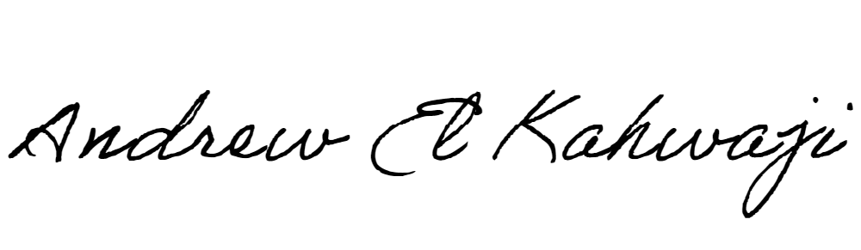

Printed Name _Andrew El Kahwaji_

Date __26/12/2024___

Email __andrew.lifesculptor.coo@gmail.com __

Phone __+961 71 914 378__